**Lesson 3 Demo 2**

**Adding Title, Headings, Paragraphs in the Webpage**

|  |
| --- |
| **Objective:** To develop a webpage that includes title, headings, and paragraphs  **Tools required:** Visual Studio Code, Browser  **Prerequisites:** None |

Steps to be followed:

1. Creating the **index.html** file
2. Adding titles, headings, and paragraphs in the webpage
3. Viewing the results in the local browser

**Step 1: Creating the index.html file**

1. Open **Visual Studio Code**, right-click on the **File** menu of the code editor, and select **New File:**

1. Create a file with the name **index.html:**

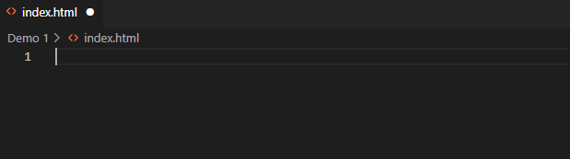

**Step 2: Adding titles, headings, and paragraphs in the index.html file.**

1. Enter the below code to view the title, heading, and paragraph in the webpage:

<!DOCTYPE html>

<html lang="en">

<head>

**<!--Code for the title-->**

<title>This is the TITLE</title>

</head>

<body>

**<!--Code for the headings-->**

<h1>This is my Webpage</h1>

<h2>This is my Webpage</h2>

<h3>This is my Webpage</h3>

<h4>This is my Webpage</h4>

<h5>This is my Webpage</h5>

<h6>This is my Webpage</h6> <br>

**<!--Code for the paragraph-->**

<p>This is the Webpage. <strong>HTML is used to develop webpages. </strong></p>

</body>

</html>

**Step 3: Viewing the results in the local browser**

1. Go to **Extensions** in **Visual Studio Code** and download **Live Server:**

1. Right-click on the **index.html** file of the project, select **Open with Live Server,** and the output obtained will be as shown below:

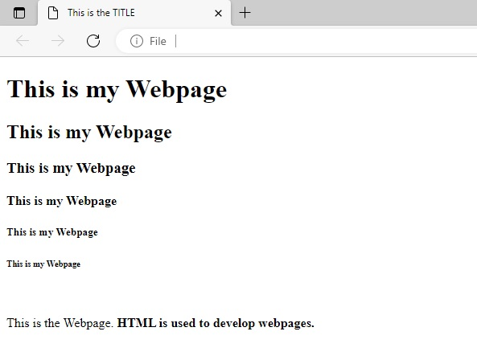

The title, headings, and paragraphs were successfully added to the webpage.